NAME: _____________ | Prob and Stats
Probability Day 6 | DATE: Monday, November 06, 2017

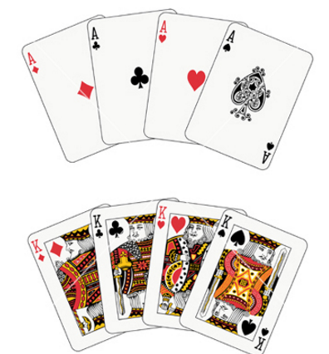
You have a deck of only 4 Aces and 3 kings.

You shuffle them up and draw 3.Find:

P( all Aces):

P (all Kings):

P (all match):

P(at least one king):

P (exactly 2 aces and 1 king) [think how many different ways could this occur?]

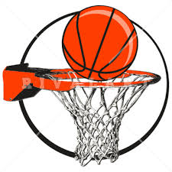
Julio is playing basketball and gets fouled “trying” to make a three pointer. He is an 80% free throw shooter. Find the probability:

P(scores all):

P(doesn’t score):

P(scores 1 point): [think of all the ways this could occur]

P(scores 2 points): [think of all the ways this could occur]

Later in the same game, he is fouled and awarded a one – and- one (which means if he makes the first he takes antoher). Find

P (he will score 2 points):

P (he will score 1 point):

P( he doesn’t score):

Lauren’s volleyball team is in the playoffs. In volleyball you play a best of 3 series. So if you win 2, the series is over. Cindy thinks she has an 80% of winning each game they play.

Find
P(Cindy wins in 2 games)

P(Cindy wins in 3 games [think of the ways that could happen])

P(Cindy’s team wins the series):

P(Other guys win in 2 games)

P(other guys win in 3 games)

P(other teaem wins series):

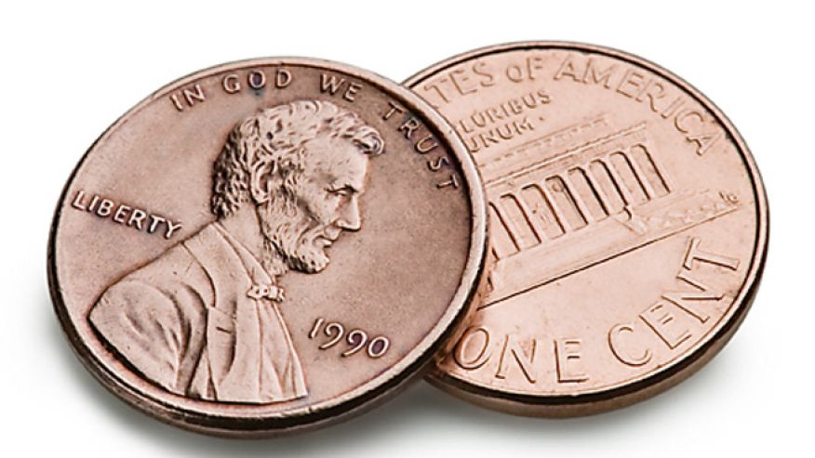
Abdisalam has two trick pennies. Each lands on heads 60% of the time (oh, he’s so sneaky). He tosses both of them?
Find:
P (2 heads):

P(2 tails)

P (one heads, one tails):

Find how many times you expect heads to appear if he plays:
- 10 times?

- 100 times?

- 1000 times?

